**Lab Exercise 2 | Week 3**

Implement ***the maximum- subarray problem.***

* 1. *Input: Array of integers.*
  2. *Output: Maximum contiguous subarray sum.*

Implement with

1. ***Brute Force Solution***: Solving it for every possible subarray.
2. ***Divide and Conquer:***
   1. Divide the given array in two halves.
   2. Return the maximum of following three
      1. Maximum subarray sum in left half (Make a recursive call)
      2. Maximum subarray sum in right half (Make a recursive call)
      3. Maximum subarray sum such that the subarray crosses the midpoint.
   3. *Example:*

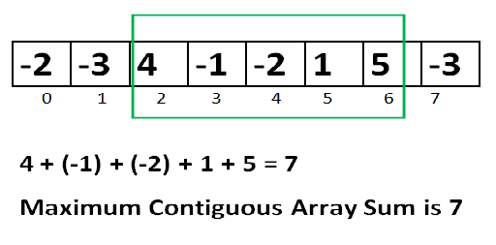

Write the analysis in detail and conclude.